How To Install Hub Motor Washers
Hub motors often come with a pile of odd looking washers. It can be confusing to determine exactly what each is for and how to install them.
However, installing these washers properly is crucial, because failure to do so can easily lead to damaging the bicycle or the motor. If the motor were to work its way out while riding due to improper installation, you could find yourself in a very dangerous situation. But don’t worry, this can all be avoided with a little education on hub motor hardware.

Hub motor hardware
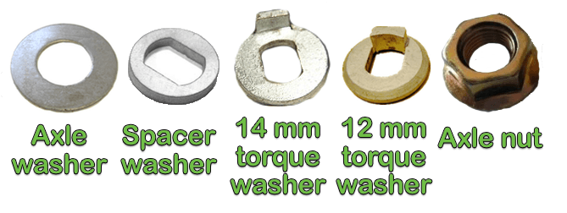Let’s start by taking a look at the diagram above with the different types of hardware that might come with your hub motor. Every hub motor should come with a minimum of axle washers, torque washers and axle nuts. Many come with spacer washers as well.
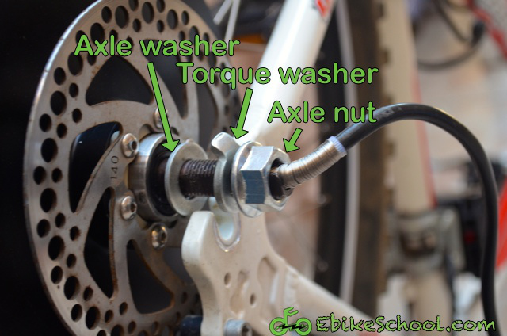
Axle washers are simply flat washers with a hole either 12 or 14 mm in diameter allowing them to slip over the axle of the hub motor. These can be placed anywhere on the axle, but generally go inside of the dropout and are the first type of washer placed on the axle.
Spacer washers are thicker than standard flat axle washers, usually 2-5mm thick. They also generally have a non-uniformly circular hole, as seen in the diagram above. These can go anywhere on the hub motor axle and are used when extra space needs to be filled. The most common uses are when the dropouts are too wide and thus the spacer washer goes inside of the dropouts, or when a torque arm needs to sit further away from the dropout, and thus the spacer washer sits outside of the dropouts.
Torque washers are used either in addition to, or in place of torque arms. They have a tooth that sits down in the dropout and helps apply the torque of the motor further from the center of the axle. The further away the force from the torque is applied, the smaller the magnitude of the force. For small geared motors of 500 watts or less, torque washers are usually sufficient. For direct drive motors of 750 watts or greater, torque arms may be required depending on the bicycle’s dropout material and design.
Axle nuts go on the outside of the dropouts and are the last thing to be placed on the axle. They secure the axle in the dropouts by keeping a constant force against the bicycle. Most axle nuts should be torqued to at least 25 newton meters. If you don’t have a torque wrench, a good strong turn on a 6 inch wrench is plenty. Some hub motors can have their axle threads strip when the axle nuts are torqued over 50 newton meters. This often occurs when someone uses a long wrench and really tries to tighten down hard. The nuts should be closed tightly, but you don’t need to overly exert yourself.

Installation of hub motor washers
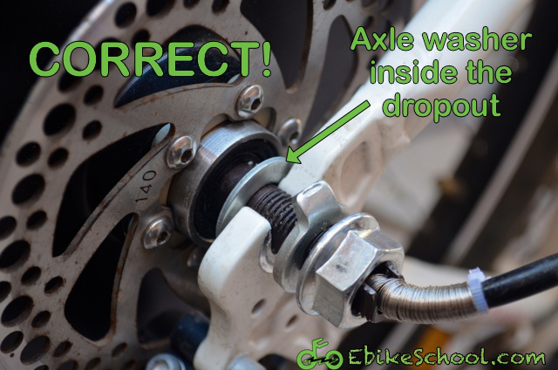
When you install your hub motor, start with an axle washer up against the shoulder of the hub motor’s axle. This washer will go inside the dropouts and give a larger surface than the axle’s shoulder to clamp against the inside of the dropouts. There should be an axle washer on both sides of the hub motor axle, inside the dropouts.
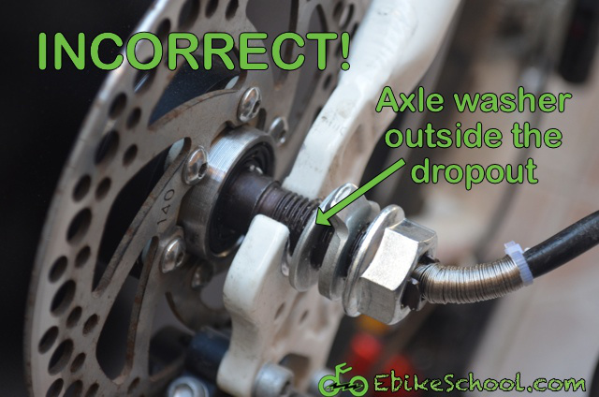
Next, if the hub-motor slips into the dropouts easily and there remains extra room for the axle washers to move up and down the length of the axle, you may need to install a spacer. One or two millimetres of wiggle room is generally ok and can be removed when you tighten the axle nuts, but any more than two millimetres can cause chain or disc brake clearance problems and overly stress aluminium frames.
If you have extra room on your axle due to extra dropout width, either use a spacer washer or a torque washer on the inside of the dropout. This should take up the extra space on the axle and may even require you to spread the dropouts slightly to slide the motor axle down into the dropouts.
If you don’t have extra room on the axle, your torque washer can go on the outside of the dropouts. The important thing to note with a torque washer is that the tooth must be down in the dropout for it to work effectively. This is rarely an issue with 12 mm torque washers, but sometimes the tooth on 14 mm torque washers sits up too high. If this is the case in your setup, just take a hammer and lightly tap the tooth back down. Sometimes it helps to use the blade of a cold chisel or an old flat head screwdriver (that beat up flat head screw driver you keep around for prying things would be perfect) to transfer the force of the hammer directly to the tooth of the torque washer.
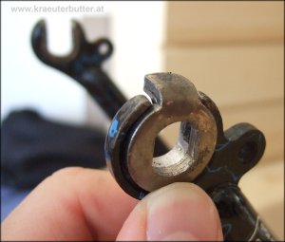
Lastly, add your axle nuts on the outside of the dropouts as the last piece of hardware on the axle. Tighten them down securely but don’t over torque them. As mentioned above, a good strong turn on a 6 inch wrench is plenty for most hub motors.
Keep in mind that this isn’t the only correct way to order your hardware. The important points here are that there is a washer up against the hub motor axle’s shoulder inside the dropouts, that the torque washer’s tooth is in the dropout gap, and that the axle nut is closed from the outside. This could also be accomplished by placing the torque washer on the axle first with the tooth facing out, then the axle nut on the outside of the dropout. This way the torque washer acts like the first axle washer in the images above by distributing the force of the hub motor axle’s shoulder against the inside of the dropout while simultaneously working like a normal torque washer by applying the torque load further from the center of the axle. In this scenario, there would only be two pieces of hardware used: the torque washer inside the dropouts and the axle nut outside the dropouts.

Torque arms
Torque arms protect your motor and frame similar to the way torque washers do, by resisting the rotational moment about the axle. However, torque arms are much stronger than torque washers. I wrote a whole article about torque arms, so I suggest starting with that as a primer if you don’t know if you need a torque arm or not. To summarize, if your hub motor is going in an aluminum fork, aluminum dropouts and/or your hub motor is over 1,000 watts, you likely need a torque arm.
A torque arm is almost always installed outside of the dropouts and before the axle nut. It is usually connected to the either the dropouts with strong glue or bolts, or to the frame with hose clamps. Here you can see a torque arm being included on the same example bike.
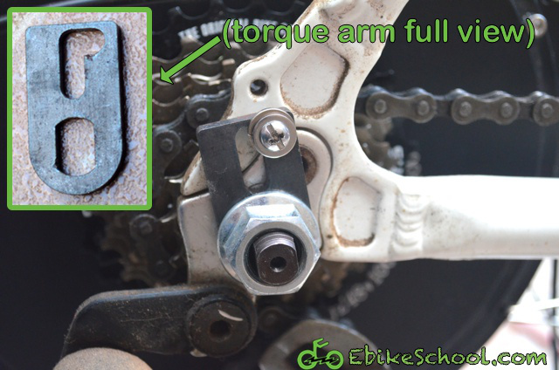

In conclusion
As you can see, installing your hub motor washers isn’t rocket science. The important factors are:
- A washer is inside the dropouts against the shoulder of the hub motor axle
- A torque washer is installed with the tooth inside the dropout gap
- A torque arm prevents the axle from rotating in the dropout (optional depending on system)
- An axle nut secures the axle from the outside
As long as those conditions are met then you should be good to go. Just remember to reinstall the washers in the correct order if you ever remove the wheel to fix a flat tire. This is especially important if you take your ebike to a local bicycle shop for a repair because most bike shops are not familiar with ebikes and might unintentionally reinstall the motor incorrectly. Always verify that your washers are correctly ordered and aligned.
Author
Micah is a mechanical engineer, tinkerer and husband. He's spent the better part of a decade working in the electric bicycle industry, and is the author of The Ultimate DIY Ebike Guide. Micah can usually be found riding his electric bicycles around Florida, Tel Aviv, and anywhere else his ebikes wind up.

